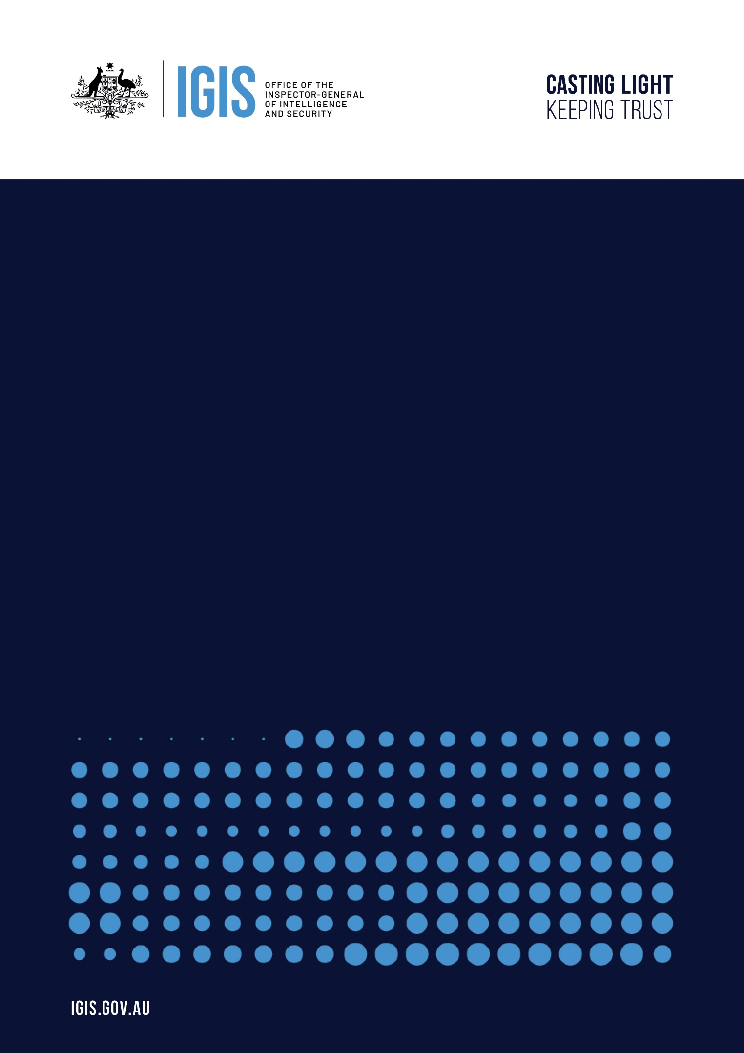
Candidate Information Kit
  - Assistant Inspector General and General Counsel
  - Senior Executive Service Band 1

Assistant Inspector-General and General Counsel

Actual and expected vacancy
Classification: | Senior Executive Service Band 1 | Salary: | $248,747 - $281,123 plus 15.4% Super
Status: | Ongoing | Close: | Sunday 22 November 2026
Type: | Full-time | Contact: | Karina Duffey, Executive Intelligence Group  admin@execintell.com.au | (02) 6232 2200
Location: | Barton, ACT | Website: | igis.gov.au
Office Arrangement: | Canberra based, flexible working arrangements negotiable

Who are we?
The Office of the Inspector-General of Intelligence and Security (OIGIS) is central to the independent oversight of the Australian intelligence and security agencies. The Inspector-General is an independent statutory office holder with oversight of the activities of Australia’s intelligence and security agencies to ensure they act legally and with propriety, comply with ministerial guidelines and directives, and respect human rights. The work of the Inspector-General and his staff provides assurance to ministers, the parliament and the public that these agencies are using their powers as intended. The Inspector-General of Intelligence and Security Act 1986 provides that the IGIS has jurisdiction over the following agencies that make up the national intelligence community:
- Office of National Intelligence (ONI)
- Australian Security Intelligence Organisation (ASIO)
- Australian Secret Intelligence Service (ASIS)
- Australian Signals Directorate (ASD)
- Australian Geospatial-Intelligence Organisation (AGO)
- Defence Intelligence Organisation (DIO)
- Australian Criminal Intelligence Commission (ACIC)
- Australian Federal Police (intelligence functions only)
- AUSTRAC (intelligence functions only)
- Department of Home Affairs (intelligence functions only)
This is a pivotal time for our agency, as our jurisdiction has recently grown and we are looking to expand our capacity to meet this new environment. There are significant opportunities to demonstrate and develop professional skills and leadership within the legal function of the agency.
We are a small portfolio agency, proud of our contribution to the national interest. We recognise that our people are our greatest asset – we recruit and retain highly capable, motivated professionals with high levels of integrity and personal drive; and we invest in, and value, their development. Further, we offer a rewarding, positive, and inclusive environment, empowering staff to work flexibly in their contribution to the achievement of agency goals.

Why work for us
At IGIS, we offer an attractive package which includes a combination of competitive remuneration, rewarding job opportunities and a high performing team environment, including:

 | Join a team of experienced leaders who drive real impact  A team of intelligent and engaged leaders committed to achieving outcomes that have a tangible impact on our community
 | Expand your skills  IGIS provides and supports professional development opportunities including further study, training, professional memberships and study assistance
 | A supportive, balanced culture  Join a supportive team environment, which embraces diversity and cultivates an inclusive environment supportive of personal growth.
 | Gain industry experience  The opportunity to enhance stakeholder engagement across a range of agencies including security and intelligence agencies
 | Access to a range of benefits  Including competitive salary and the potential for other allowances and benefits, 15.4% superannuation, supportive wellbeing initiatives, including increased health and wellbeing allowances and additional miscellaneous leave each quarter, and the option to purchase leave
 | Commitment to exploring and enabling flexibility  We support and encourage flexible working arrangements, including family friendly, caring and genuine part-time provisions, to support a healthy work-life balance

The Opportunity
The Assistant Inspector-General and General Counsel leads the Legal and Governance Branch and is the principal source of legal advice to the Office of the Inspector-General of Intelligence and Security. The role holds accountability for the governance framework through which OIGIS meets its own obligations as a Commonwealth entity, and exercises the Chief Risk Officer function.

The role requires extensive expertise in public law, administrative law and statutory interpretation, together with significant experience in public inquiries and legislative processes. Recognised as the authoritative source of legal advice within OIGIS, the occupant exercises critical judgement in an environment where precedent is limited and where advice shapes how inquiries and inspections are framed and conducted. The role also leads OIGIS’s corporate governance, enterprise risk management, internal audit and statutory reporting, and holds carriage of ministerial and parliamentary services.

As a member of the Executive, the role contributes to setting the strategic direction of OIGIS, not only to the leadership of its own Branch. The legal function serves every Branch, while the governance role oversees the regulatory, risk management and associated frameworks within which OIGIS operates. The role is expected to work across Branch boundaries and to proactively identify changes to policy or legislation that would enable OIGIS to contribute more effectively to the oversight of the National Intelligence Community.

High-level stakeholder management is essential, involving interaction with agencies within the National Intelligence Community, the Attorney-General’s Department and the Attorney-General’s Office, parliamentary committees, the Australian National Audit Office and central agencies. The role demands professional and public administration expertise, sound judgement under pressure, and the ability to operate in a complex and wholly classified environment.

Key responsibilities for an Assistant Inspector-General and General Counsel include:
- Strategic leadership: Contribute as a member of the Executive to setting the strategic direction of OIGIS. Proactively identify changes to policy or legislation that would enable OIGIS to contribute more effectively to the oversight of the National Intelligence Community, and lead OIGIS’s position on them. The role is expected to anticipate and shape the legal and policy questions facing OIGIS, not only to resolve those that arise.
- Corporate and cross-Branch leadership: Contribute to decisions on matters affecting OIGIS as a whole. Actively manage the interfaces between the Branch and others, including work that is shared, sequential or contested. Identify and resolve boundary issues as they arise. Support consistency of approach where OIGIS presents a single position externally, and contribute to strategic planning, resource allocation and workforce decisions. Lead change arising from structural or functional reform across OIGIS.
- Legal authority: Lead the legal function and provide authoritative advice on the Inspector-General of Intelligence and Security Act 1986, the Intelligence Services Act 2001, the Australian Security Intelligence Organisation Act 1979 and related legislation, such that OIGIS can act with confidence in the legal positions it takes in its dealings with agencies within OIGIS’s jurisdiction. Advise on statutory interpretation where precedent is limited or absent. Provide legal advice to the Inspector-General and to staff on OIGIS’s own internal operations, including human resources, procurement, contracts and information technology. Act as OIGIS’s escalation point on questions of law and manage the engagement of external legal services.
- Legislative and policy development: Lead OIGIS’s contribution to legislative development and new policy proposals affecting its jurisdiction and ensure that OIGIS’s internal policy framework and broader policies meet all relevant legal requirements.
- Leadership of the legal and governance teams: Lead and manage both teams, setting the tone and direction for each. Drive continuous improvement in the quality and timeliness of the Branch’s advice and outputs, establish clear standards, and hold the Branch to them. Mentor and develop staff and build the Branch’s capacity to deliver.
- Governance, risk and assurance: Maintain OIGIS’s corporate governance framework and committee arrangements, lead compliance with the Public Governance, Performance and Accountability Act 2013, oversee the internal audit program and support the Audit and Risk Committee, and lead preparation of the Corporate Plan and Annual Report. As Chief Risk Officer, own the enterprise risk management framework, recommend risk appetite and tolerance, lead business continuity management, and embed a positive risk culture across all Branches.
- Assurance to the accountable authority: Provide the Inspector-General, as accountable authority under the Public Governance, Performance and Accountability Act 2013, with assurance that OIGIS is meeting its legal, regulatory and risk management requirements.
- Integrity: Determine and manage public interest disclosures concerning OIGIS’s own officers, maintaining fairness, procedural consistency and timeliness in matters of significant sensitivity.
- External stakeholder engagement: Represent OIGIS in its dealings with agencies within the National Intelligence Community and hold peer standing with General Counsel and senior officers across those agencies and in relevant departments. Hold carriage of OIGIS’s engagement with the Attorney-General’s Office and support its engagement with the Parliamentary Joint Committee on Intelligence and Security.
- Resource management: Plan and manage the Branch’s budgeted resources, anticipating future needs and allocating effort to areas of highest risk and value.

To be successful in this role you will have:
- Integrity: Upholds the professional and ethical standards required of OIGIS’s legal adviser and of the officer determining disclosures concerning its own staff. Exemplifies the APS Values and Behaviours, including Stewardship.
- Working in Government: Discharges OIGIS’s parliamentary, ministerial and PGPA obligations with a sound understanding of the context in which OIGIS operates and its role within government. Demonstrates current and detailed knowledge of Australian Public Service governance and risk management frameworks and practices.
- Strategy, Policy and Evaluation: Applies strategic analysis to corporate planning, enterprise risk and internal audit and to OIGIS’s own performance. Identifies opportunities in policy and legislation for OIGIS to contribute more effectively to the oversight of the National Intelligence Community.
- Leadership and Management: Leads the Branch and contributes to the leadership of OIGIS. Inspires and guides a multidisciplinary team towards shared objectives and develops the capability of others.
- Engagement and Partnership: Builds and sustains the relationships on which the legal and governance functions depend, within OIGIS and beyond it, and articulates complex legal and governance concepts to a range of audiences. Carries standing as a peer among senior legal and executive officers across the National Intelligence Community.
- Legal expertise: Extensive knowledge of public law, administrative law and statutory interpretation, with a proven ability to provide strategic legal advice in complex and classified environments at a level that gives OIGIS confidence in the positions it takes.
- Cultural capability: Contributes to a culturally safe workplace and extends their own cultural learning, consistent with the SES Performance Leadership Framework.

Qualifications and Experience
- A degree in law, together with admission to practise and the ability to hold an unrestricted practising certificate in the Australian Capital Territory or another Australian state or territory.
- Extensive experience in public law, administrative law and statutory interpretation.
- Demonstrated experience leading legal and multidisciplinary teams, setting direction and standards, and lifting the quality and timeliness of a team’s output.
- Demonstrated knowledge of Australian Public Service governance and risk management frameworks and practices, sufficient to provide assurance to an accountable authority.
- Experience operating at senior executive or equivalent level in a Commonwealth legal function, sufficient to engage with General Counsel across the National Intelligence Community and relevant departments as a peer
- A proven record in contributing to policy and legislative reform and in identifying where legislative or policy change would improve outcomes.
- Experience in a National Intelligence Community agency or another regulatory, oversight or investigative setting is highly regarded.
- Ability to obtain and maintain a Top-Secret Positive Vetting (TSPV) security clearance.

Security, suitability and integrity requirements
- Citizenship - you must be an Australian citizen

- Employment Suitability Assessment (ESA)– appointment to our Office depends on the outcome of an ESA.

- Security Clearance – appointment and ongoing employment at the Office are subject to a Positive Vetting/Privileged Access clearance being granted and maintained. You must be willing to undergo a security clearance vetting process at the Top-Secret Positive Vetting/Privileged Access clearance level and must be willing to fully cooperate in the assessment process, including the timely provision of information and documentary evidence. Security vetting may take many months to complete and requires candidates to provide significant personal information to the vetting authority.
Positions at IGIS are positions of trust. In addition to the above, all IGIS staff are required to make annual conflict of interest declarations to support the independence and integrity of the Office.
The successful candidate must be located in Canberra or willing to relocate. The IGIS offers relocation assistance to new employees relocating to Canberra from interstate.

How to apply
Applicants must be submitted through the Executive Intelligence Group application portal by 11:30pm AEST on Sunday 22 November 2026.
NOTE: All applications must be provided at the OFFICIAL level. Classified applications will not be accepted.
As part of your application you will need to provide:
- your current resume;
- contact details of two referees (one of these must be your current supervisor/manager)
- a written statement explaining why you are interested in IGIS and how your education, skills, knowledge and experience make you suitable for the position (maximum 750 words)

When framing your response, you should also refer to the:
- SES Performance Leadership Framework. This sets the expectations for all SES employees.
- Secretaries Charter of Leadership Behaviours. This sets out the behaviours Secretaries expect of themselves, the SES and across all levels of the APS. The Charter focuses on behaviours that support modern systems of leadership within the construct of the APS Values and Code of Conduct.
- Integrated Leadership System upon which the above behaviours are built.

Please note:
- You should receive an automated e-mail confirmation that your application has been received. If you do not receive this, please contact Executive Intelligence Group on the details below.
- If at any time, you wish to withdraw from this process you will need to send an email to admin@execintell.com.au to let us know. You are unable to withdraw your application directly from the website.

Contact
If you would like more information about the position, please contact Karina Duffey at Executive Intelligence Group on 02 6232 2200 or by email at admin@execintell.com.au.

Frequently Asked Questions

What should I include in my resume?
The quality of your resume creates the first impression we have of you. As a minimum you should ensure that you include the following elements:
- personal details – include your name, contact email address and phone numbers
- education – provide details of any education and qualifications that relate to the position you are applying for
- work experience – include all work experience and outline the main responsibilities and achievements that are relevant to the position for which you are applying. Organise your employment history in chronological order, starting with the most recent, and indicate actual dates of employment. Make sure to explain any gaps in time
- referees – include the name and contact details of two professional referees who can validate and support your application. One referee should be your current supervisor.
- layout – no longer than 4 pages. Use an easy to read font and a simple consistent format. Use bullet points to break up text. Place key information on the front page where it can be noticed. Highlight important facts, and ensure that you can back them up with examples if asked at interview.

What should I include in my statement?
Your 750-word statement is a chance to persuade us that you would be an excellent Assistant Inspector-General and General Counsel. We want to know why you want to work for the IGIS, why you are interested in the role, what you can offer us and how your skills, knowledge, experience and qualifications are applicable to the role.

How will my application be assessed?
All selection decisions are based on merit which means that:
- the assessment process is fair and consistent
- assessment is based on position specific requirements for the position – things that are genuinely required for someone to perform the role at the respective classification
- as evaluated, the best person for the position is offered the position.
Your written statement will be assessed by members of a selection committee using the APS Work Level Standards. In doing so, you will be judged on your ability to demonstrate that you possess - or have the real potential to develop - the required skills, knowledge, experience and qualifications to perform the role.
These requirements are based on the information provided to you as part of the position advertisement. If you are shortlisted you may be asked to undertake further assessment to test your ability to perform the role. This may include testing your written communication skills.
In the event that more than the required number of suitable candidates is identified, a merit pool may be established and maintained to fill similar vacancies in Canberra within an 18-month period, should they arise.

